**System Design and Architecture**

**ERD Diagram:**

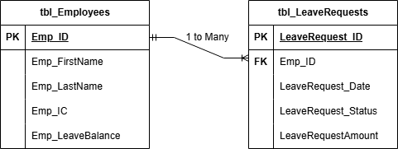

The ERD will contain 2 tables which will be sufficient for all the requirements and logic of the system. 2 Tables, Employee table which will hold the employee information and their leave balance. Leave Request table which will hold the employee leave requests, which will contain the Number of days they want to leave and the Date the leave should start as per their request. Each leave will have a status and can be displayed to the employee. 1 employee can have multiple leave requests, many leave requests belong to 1 employee.

**Client-Side Interface:**

The client side will contain the User interface to operate the system. There will be 2 login portals. One for HR with hardcoded username and password. One for the Employee where they can log in using their registered IC by the HR.

**HR Portal Features:**

* HR will have the option to add a new employee.
* HR will have the option to edit current employee details.
* HR will have the option to view leave requests and if needed, enter an IC to view specific employee leave requests.
* HR will be able to update leave requests status to one of the three: **Pending, Approved, Denied.**
* HR will have the option to generate yearly report of Leave history of an employee. This report will be extracted to PDF or Excel, we are flexible to choose.

**Employee Portal Features:**

* Employees will have the option to view their current details.
* Employees will have the option to apply a leave request.
* Employees will have the option to view their current leave request status.
* Employees will have the option to view their leave request history.

**Server-side Logic:**

The client will communicate with the server. Any features stated above requested by the client will be sent to the server to process and return data. The server will handle the system, Querying and Updating of the database, handling the logic of leave balance, generating reports, and other parts, making sure that it can handle all requests.

Data being sent from the server can be in JSON format or another suitable format, for the client to receive and display accordingly.

**Conclusion:**

* Client Side will mainly have the UI/UX to allow users to interact and request services from the Server.
* Client Side will have the UI/UX to display any data necessary that is retrieved from the server.
* ***NOTE: The UI/UX design will be further discussed together to make sure it aligns with the requirements. We will be using JFrames for the UI/UX.***
* Server side will handle all requests sent from the client side.
* Server side handle all logic of the systems and DB queries.
* Data sent back from server should preferably be in JSON format, that is then parsed by the client and displayed accordingly.

**Preferred Responsibility:**

Ahmed & Adnim (Client Side)  
Ali & AbduZafar (Server Side)

This can be further discussed if there are any remarks.